**Transfer Learning**

Transfer learning is a research problem in machine learning that focuses on storing knowledge gained while solving one problem and applying it to a different but related problem. For example, knowledge gained while learning to recognize cars could apply when trying to recognize trucks. This area of research bears some relation to the long history of psychological literature on transfer of learning, although formal ties between the two fields are limited.

Transfer learning is a machine learning method where a model developed for a task is reused as the starting point for a model on a second task. Transfer Learning differs from traditional Machine Learning in that it is the use of pre-trained models that have been used for another task to jump start the development process on a new task or problem.

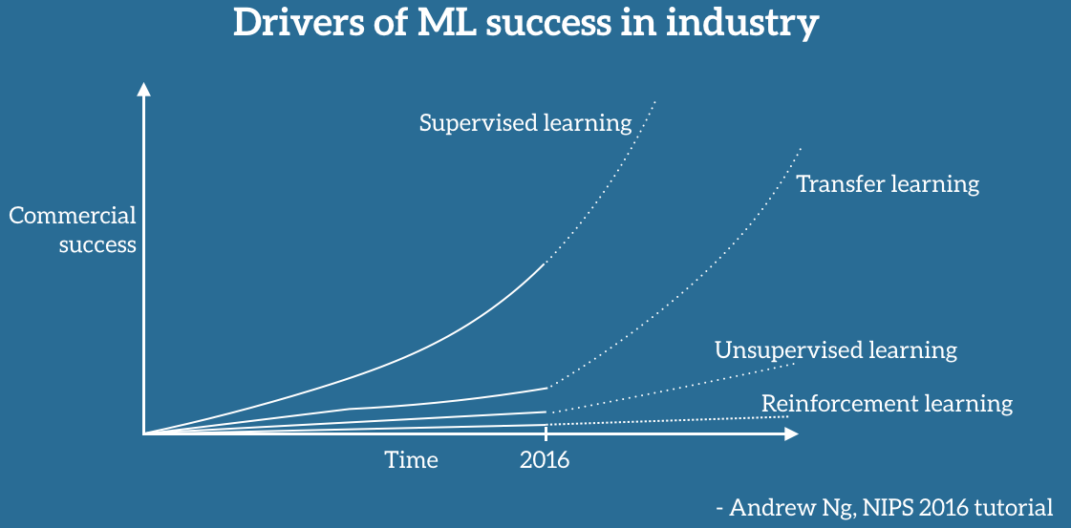

Andrew Ng 2016 NIPS

Transfer learning involves the concepts of a domain and a task. A domain DD consists of a feature space XX and a marginal probability distribution P(X)P(X) over the feature space, where X=x1, ⋯, xn∈XX=x1, ⋯, xn∈X. For document classification with a bag-of-words representation, XX is the space of all document representations, xixi is the ii-th term vector corresponding to some document and XX is the sample of documents used for training.

The benefits of Transfer Learning are that it can speed up the time it takes to develop and train a model by reusing these pieces or modules of already developed models. This helps speed up the model training process and accelerate results.

**Transfer Learning Examples:**

**1. Image Classification using Inception V3 as a starting point.**

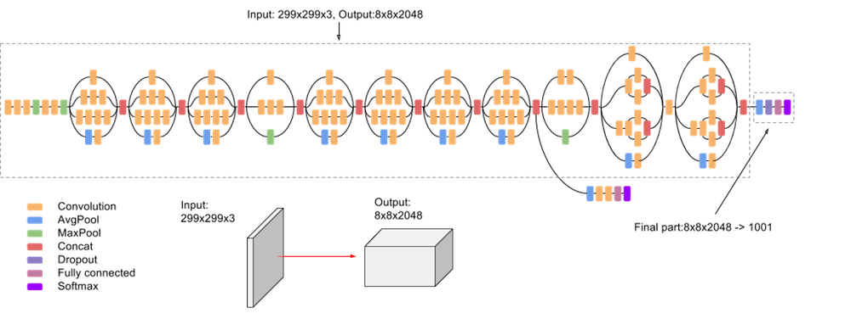

**Description:**Transfer Learning used to speed up Image Classification using Inception V3 as a starting point for transferring modules.

# **2. Transfer Learning with a Warm Restart**

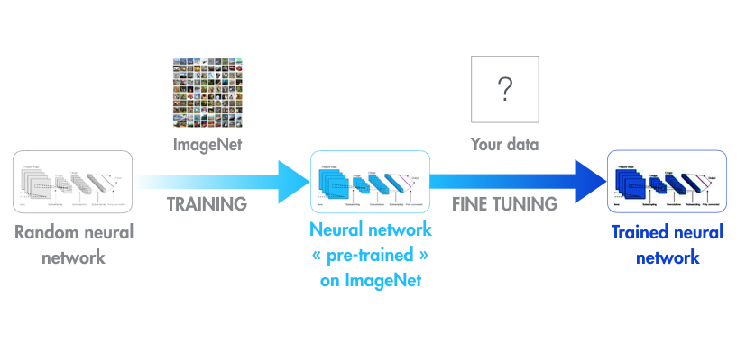

Often many Machine Learning questions offer datasets that may be very horizontal and not conducive to applying a ML solution initially. To account for this, we can train a Deep Convolutional Neural Net on ImageNet and then use a technique called a Warm Restart to refine the algorithm on the “target” dataset.

By pre-training the neural network on ImageNet, we can then re-use it on your target data set as the lower layers are already trained on recognizing shapes and sizes. we can the refine the upper layers for our target data set.

# **3. VR Enabled Imitation Learning**

The rapid development of VR environments has created an opportunity for models, agents and algorithms to train in virtual environments and then apply the learning and models from the environment to the real world. An example of that is training a self-driving car in a virtual environment simulating actual cities and then using those trained algorithms to learn from its mistakes before deploying in the real world.

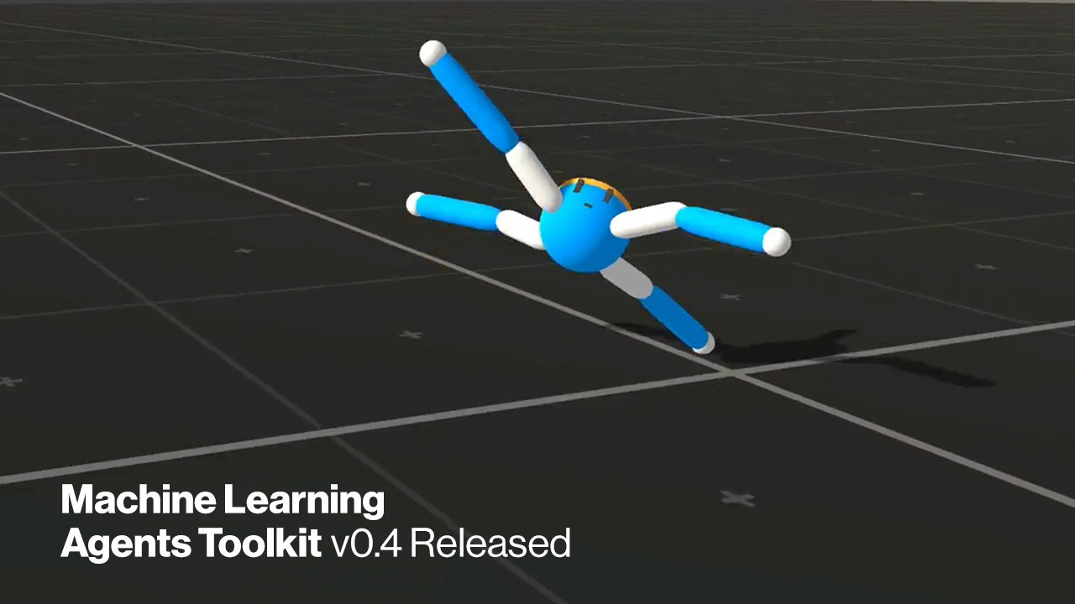

Unity Technologies has done a fantastic job of creating virtual training tool kits where Neural Nets can be trained in virtual environments. The Unity ML-Agents Toolkit v0.4 is released and an excellent tool for using Imitation Learning and training Neural Nets.

# 4. Using Modules from Pre-Trained Models

Models that have already been trained on large data sets can often lend parts of their code to other models. This is sometimes referred to as using modules to build a new model on a new data set. This is another method for speeding up the model building process and gaining efficiencies in our Machine Learning workflow.

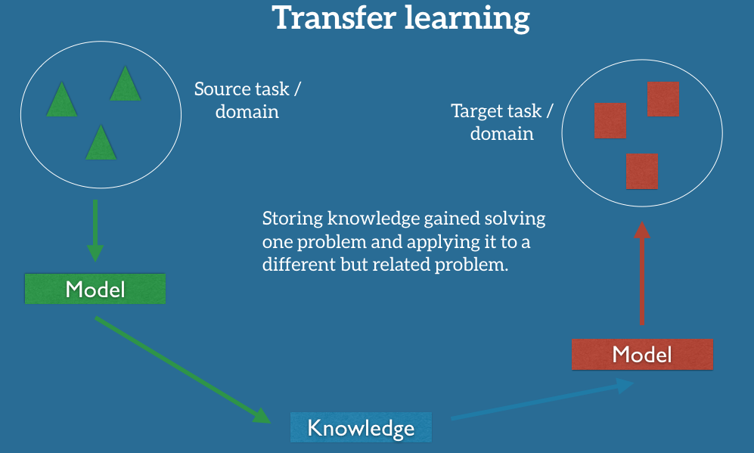

**Popular Pre-trained Models**

* Inception-v3 model, which was trained for the ImageNet “Large Visual Recognition Challenge."
* Microsoft also offers some pre-trained models, available for both R and Python development, through the MicrosoftML R package and the Microsoftml Python package.
* Other quite popular models are ResNet (Short for Residual Network. most popularly used for image classification)
* And AlexNet (a significantly “old” image classification algorithm that performs well on ImageNet.)

# **5. Meta Learning. Learning to Learn.**

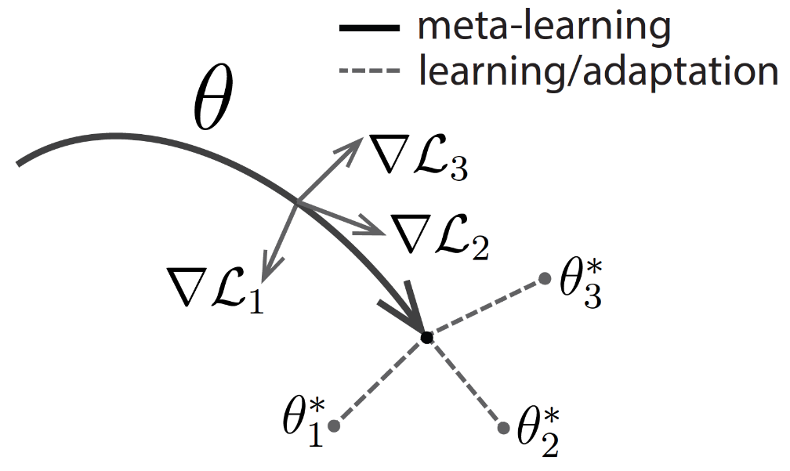

Meta Learning is an approach where the algorithm or agent teaches itself by being exposed to a large number of tasks and tested on their ability to learn new tasks. This differs from many standard machine learning techniques, which involve training on a single task and testing on held out examples from that task. Transfer Learning is also involved in Meta Learning as the agents apply skills learned in one scenario to others.

There are a variety of Meta-Learning Models some of them include:

* Few Shots Meta-Learning: Create deep neural networks that can learn from minimalistic data sets.
* Optimizer Meta Learning: Learn how to optimize a neural network to better accomplish a task.
* Metric Meta-Learning: Determine a metric space in which learning is particularly efficient.
* Recurrent Model Meta Learning: A Meta Learning algorithm trains an RNN model.

Transfer learning is useful when we have insufficient data for a new domain we want handled by a neural network and there is a big pre-existing data pool that can be transferred to our problem. So, we might have only 1,000 images, but by tapping into an existing CNN such as ResNet, trained with more than 1 million images, we can gain a lot of low-level and mid-level feature definitions. Transfer learning will become a key driver of Machine Learning success in industry.

In summary, there are many exciting research directions that transfer learning offers and in particular many applications that are in need of models that can transfer knowledge to new tasks and adapt to new domains. I hope that I was able to provide you with an overview of transfer learning.

**References:**

* <https://www.tensorflow.org/tutorials/images/transfer_learning>
* <https://medium.com/kansas-city-machine-learning-artificial-intelligen/an-introduction-to-transfer-learning-in-machine-learning-7efd104b6026>
* <https://medium.com/kansas-city-machine-learning-artificial-intelligen/an-introduction-to-transfer-learning-in-machine-learning-7efd104b6026>
* <https://towardsdatascience.com/a-comprehensive-hands-on-guide-to-transfer-learning-with-real-world-applications-in-deep-learning-212bf3b2f27a>
* <https://ruder.io/transfer-learning/>
* <https://en.wikipedia.org/wiki/Transfer_learning>
* <https://machinelearningmastery.com/transfer-learning-for-deep-learning/>